Healthcare Revenue Cycle Management (RCM) Analytics (Claims, Payments, Denials & Accounts Receivable)

1. Project Overview and Objective
This project focuses on analyzing US Healthcare Revenue Cycle Management (RCM) data using Python and Power BI. The analysis covers healthcare claims, payments, denials, outstanding Accounts Receivable (AR), payer and provider performance, AR aging, and claim follow-up activities.
The main objective is to clean and transform the healthcare claims data using Python and develop an interactive Power BI dashboard to identify meaningful patterns, trends, and business insights that support better claim resolution, denial management, AR monitoring, and revenue cycle performance.

2. Data Sources
- Source Description and Timeline: GitHub and Data collected during 2019 to 2024.
Link: https://github.com/imranbdcse/healthcaredatasets
- Domain: US Healthcare – Revenue Cycle Management (RCM), Medical Billing, Claims, Payments, Denials and Accounts Receivable (AR) Analytics

3. Problem Statement
- To analyze healthcare claims and payment performance to identify patterns in billed, allowed, paid, and outstanding amounts.
- To examine denial patterns across payers and denial categories to identify major causes of claim rejections and opportunities for denial reduction.
- To evaluate Accounts Receivable (AR) aging and outstanding claims to identify high-value and long-pending claims requiring immediate follow-up.
- To assess payer, provider, follow-up, and appeal performance to identify operational gaps affecting claim resolution and revenue collection.
- To provide actionable insights through Python analysis and an interactive Power BI dashboard to support better claim management, reduce outstanding AR, improve payment collection, and optimize overall Revenue Cycle Management performance.

4. Attribute (Column /Features) Details:

Attribute Name | Data Type | Description
Claim_ID | Integer / String | Unique identifier for each healthcare claim
Name | String (Text) | Name associated with the claim/patient record
Age | Integer | Age of the patient in years
Gender | Categorical | Gender of the patient
Medical Condition | Categorical | Medical condition associated with the claim
CPT_HCPCS_Code | Integer | Procedure or service code associated with the claim
Procedure_Description | String (Text) | Description of the medical procedure or service
Provider_ID | Integer / String | Unique identifier for the healthcare provider
Provider_Name | String (Text) | Name of the healthcare provider
Facility_Name | String (Text) | Name of the healthcare facility
Payer_Name | String (Text) | Name of the insurance payer
Payer_Type | Categorical | Type of payer, such as Commercial or Government
State | Categorical | State where the healthcare service was provided
Region | Categorical | Geographical region associated with the claim
Date of Admission | Date | Date on which the patient was admitted
Discharge Date | Date | Date on which the patient was discharged
Claim_Submission_Date | Date | Date on which the claim was submitted to the payer
Claim_Month | Date/Period | Month in which the claim was submitted
Claim_Year | Integer | Year in which the claim was submitted
Claim_Status | Categorical | Current status of the claim, such as Paid, Denied, or Partially Paid
Billed_Amount | Numeric | Amount billed to the payer for the service
Allowed_Amount | Numeric | Amount allowed by the payer according to the claim
Contractual_Adjustment | Numeric | Amount adjusted based on payer contract or fee schedule
Paid_Amount | Numeric | Amount actually paid by the payer
Outstanding_Amount | Numeric | Amount remaining unpaid on the claim
Denial_Code | Integer / String | Code representing the reason for claim denial
Denial_Reason | String (Text) | Explanation for why the claim was denied
Denial_Category | Categorical | Classification of the denial, such as Contractual, Technical, Eligibility, or Authorization
Denial_Amount | Numeric | Amount associated with the denied portion of the claim
Posting_Rep | Integer / String | Representative responsible for payment posting
Payment_Posting_Date | Date | Date on which the payment was posted
Admission Type | Categorical | Type of patient admission
DOS | Date | Date of service for the healthcare claim
Days_Outstanding | Integer | Number of days the claim amount has remained outstanding
AR_Aging_Bucket | Categorical | Aging classification of outstanding AR, such as 0–30, 31–60, 61–90, and 90+ days
Assigned_AR_Rep | Integer / String | AR representative assigned to follow up on the claim
Priority | Categorical | Priority level assigned to the claim, such as High, Medium, or Low
Follow-up_Status | Categorical | Current status of AR follow-up activity
Appeal_Status | Categorical | Status of the claim appeal, such as Filed, Won, Lost, or In Progress
Last_Follow-up_Date | Date | Most recent date on which claim follow-up was performed
Next_Action | Categorical | Next action required to resolve the claim
Escalation_Flag | Categorical | Indicates whether the claim requires escalation
Resolution_Amount | Numeric | Amount resolved through AR follow-up or claim resolution
Remaining_Outstanding | Numeric | Outstanding amount remaining after resolution activity

5. Tools & Technologies
- Python: Data cleaning, preprocessing, exploratory data analysis (EDA), data transformation, and data visualization using Pandas, NumPy, Matplotlib, and Seaborn.
- Power BI: Data modelling, DAX calculations, KPI development, visualization, and interactive dashboard creation.

6. Data Pre-Processing (Python / Power Query)
Tasks Performed:
- Data Cleaning & Transformation:
- Removed duplicates on all 44 columns.
- Missing values handled contextually:
Not with blanket fill: Age → median; Gender → standardized to M/F;
Medical Condition ↔ CPT_HCPCS_Code ↔ Procedure_Description → cross-imputed using grouped mode (each field's most common value for that specific code/condition, not a global average);
Provider_ID ↔ Provider_Name → cross-filled via groupby mode;
Claim_Month → derived from Discharge Date when missing.
- Formats standardized:
Name fields title-cased; Gender codes unified;
date-derived fields (Claim_Month) forced to a consistent yyyy-MM string format.
- Calculated fields created two layers:
- in Python:
Allowed_Amount (Billed − Contractual_Adjustment),
Outstanding_Amount (Allowed − Paid),
Denial_Category built from a manual Denial_Reason mapping dictionary;
- in Power BI/DAX:
the 10 measures above (Collection Rate, Denial Rate %, Adjustment Rate, etc.), which are the report-layer calculated fields that actually drive the KPI cards on your dashboard.
- Filtering & Sorting:
- AR_Aging_Bucket ordered on a custom logical sequence (0-30 → 365+), not alphabetically - same logic reused in Power BI as a sort-by-column so the aging axis reads correctly on visuals.
- Claims filtered/grouped by Payer_Type and Claim_Status to isolate Denied/Partially Paid records for follow-up.
- Dashboard-side filtering is handled live via the Region slicer and Month/Quarter/Year date slicer on Page 1, letting a viewer re-sort/re-filter the same cleaned data interactively instead of relying on static Excel sorts.
- Pivot Tables: Generated Pivot Tables for data summarization and initial insights.
  - Python pivot: Payer_Type × AR_Aging_Bucket (sum of Outstanding_Amount) and Payer_Type × Claim_Status — your "initial insight" layer
  - These pivots map directly onto dashboard visuals: the column chart (Billed/Paid/Outstanding by Payer_Name) and pie/bar charts on the AR Aging & Denial page are essentially live, interactive versions of those same pivot summaries.
- Convert the data into Fact and Dimension Table (If Possible)
- The cleaned dataset (`Cleaned_Dataset_-_Updated.csv`, 55,390 rows) was normalized into a star schema — 1 fact table and 8-dimension tables — to support efficient relational modeling in Power BI.
Table | Description
Fact_Claims | Core transactional table — one row per claim, holding all FK references and financial measures (Billed, Paid, Outstanding, Denial amounts, Days_Outstanding)
Dim_Patient | Patient demographics (Name, Age, Gender, Medical Condition)
Dim_Provider | Provider ID and name
Dim_Facility | Facility name, State, Region
Dim_Payer | Payer name and type (Commercial/Government)
Dim_Procedure | CPT/HCPCS code and procedure description
Dim_Denial | Denial code, reason, category
Dim_Staff | AR reps / posting reps (normalized from two naming formats)
Dim_Date | Role-playing date dimensions used across Admission, Discharge, Submission, Posting, and Follow-up dates

7. Data Visualization & Chart Interpretation (Power BI Dashboard):

- Univariate Analysis – Claim Status Distribution (Donut Chart):

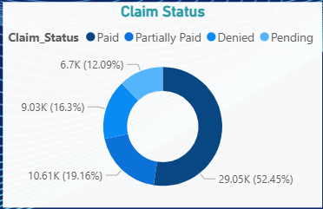

Interpretation of above chart
Analysis: Univariate Analysis
Visualization: Donut Chart – Claim Status Distribution
Chart Explanation:
The donut chart shows the proportional split of all 55,390 claims across their final status: Paid, Partially Paid, Denied, and Pending.
Purpose:
To get a quick, single-glance read on overall claim resolution health without digging into dollar values.
Features Used:
Claim_Status, Claim_ID (count)
Business Insight:
Only 52.4% of claims (29,053) are fully Paid. The remaining 47.6% is split across Partially Paid (19.2%), Denied (16.3%), and Pending (12.1%) — meaning nearly half of all claims require some form of follow-up, appeal, or rework before revenue is fully realized.

- Trend Analysis – Billed/Paid/Outstanding by Claim Year (Combo Chart):

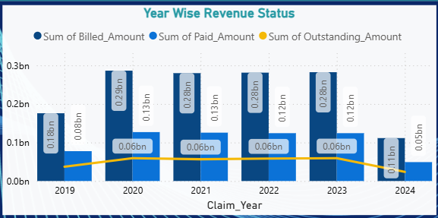

Interpretation of above chart
Analysis: Trend Analysis (Time-Series)
Visualization: Combo Chart (Line + Clustered Column) – Billed/Paid/Outstanding by Claim_Year
Chart Explanation:
The combo chart tracks Billed, Paid, and Outstanding amounts year-over-year from 2019 to 2024, with columns for absolute values and a line for the collection rate trend.
Purpose:
To assess whether collection performance is improving, declining, or stagnant as billing volume scales.
Features Used:
Claim_Year, Billed_Amount, Paid_Amount, Outstanding_Amount
Business Insight:
Despite billed volume growing from $175.9M (2019) to a peak of $286.4M (2020) and staying above $280M through 2023, the collection rate has stayed flat at 44.0–44.8% every single year. This is a critical finding: revenue cycle performance has not improved at all over 6 years even as claim volume grew — process inefficiencies are scaling with the business rather than being resolved.

- Financial Risk by Medical Condition (Bar Chart):

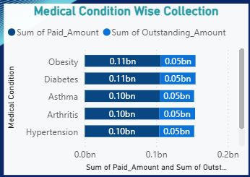

Interpretation of above chart
Analysis: Bivariate Analysis
Visualization: Bar Chart – Outstanding & Paid Amount by Medical Condition
Chart Explanation: Compares Outstanding_Amount and Paid_Amount across the 6 medical conditions in the dataset.
Purpose: To check whether financial risk is concentrated in specific medical conditions.
Features Used: Medical Condition, Outstanding_Amount, Paid_Amount
Business Insight: All 6 conditions sit within a tight band — Outstanding ranges only $48.1M–$49.9M and Paid ranges $102.1M–$106.5M. This near-identical spread shows revenue-cycle risk is not driven by clinical condition type; the problem is systemic/process-based, not specific to any diagnosis.

- Denial Resolution Performance by Category (Area Chart):

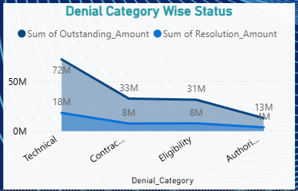

Interpretation of above chart
Analysis: Diagnostic Analysis
Visualization: Area Chart – Outstanding vs Resolution Amount by Denial Category
Chart Explanation: Plots Outstanding_Amount against Resolution_Amount for each of the 4 denial categories, showing how much of each category's denied value has actually been recovered.
Purpose: To identify which denial category is both the largest problem and the slowest to resolve.
Features Used: Denial_Category, Outstanding_Amount, Resolution_Amount
Business Insight: Technical denials are the biggest gap: $71.9M outstanding vs. only $18.3M resolved — a 25.5% resolution rate, the lowest of all categories (Eligibility resolves 24.7%, Contractual 23.5%, Authorization 28.4%). The largest denial category is also making the least recovery progress, making it the top priority for process fixes.

- AR Aging and Resolution Performance (Pie Chart):

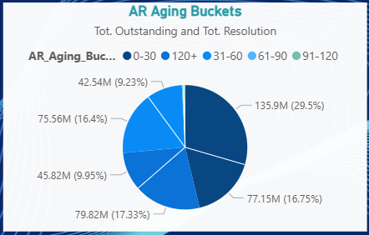

Interpretation of above chart
Analysis: Multivariate Analysis
Visualization: Pie Chart – AR Aging Bucket by Outstanding & Resolution Amount
Chart Explanation: Breaks down Outstanding_Amount and Resolution_Amount across the 5 aging buckets (0–30, 31–60, 61–90, 91–120, 120+ days).
Purpose: To see whether older claims are harder to resolve than newer ones.
Features Used: AR_Aging_Bucket, Outstanding_Amount, Resolution_Amount
Business Insight: Resolution rate is surprisingly flat across age — 0–30 days resolves 56.8%, 31–60 days 56.3%, and even 120+ days still resolves 57.4%. Age alone isn't slowing recovery; the bottleneck is claim volume stuck in the 120+ bucket ($79.8M, 14,846 claims), not declining recovery capability over time.

8. Analysis and Visualizations (Power BI)
Dashboard Features:
Pages:
1. Executive Summary textbox (top of page)
This dashboard tracks the full revenue cycle — from claims billed through collections, adjustments, and denials — giving RCM teams a single view of cash performance, payer behavior, and where revenue is currently leaking in the process."

2. KPI card captions (one-line, sits under each card)
- Total Billed → "Gross charges submitted across all payers and facilities for the selected period."
- Total Collection → "Cash actually realized against billed charges — the truest measure of RCM performance."
- Collection Rate → "Share of billed revenue successfully collected; the primary efficiency benchmark for the cycle."
- Total Claims / Allowed Claims → "Volume processed vs. volume approved by payers — a quick read on clean-claim quality."
- Denied Claims / Denial Rate → "Claims rejected by payers; rising denial rate signals coding, eligibility, or documentation gaps upstream."
- Total Outstanding / PMT Outstanding Rate → "Revenue still tied up in AR — the balance still owed once approvals and payments are netted out."
- Total Adjustment / Adjustment Rate → "Contractual write-offs and negotiated discounts removed from billed charges before collection."

3. Chart-specific insight comments
- Claim Status (donut) → "Distribution of claims by lifecycle stage — use this to spot bottlenecks between submission and final settlement."
- State Wise Collection Status (bar) → "Highlights which states/regions are converting billed revenue into cash fastest — useful for reallocating collections staff."
- Medical Condition Wise Collection (bar) → "Shows which service lines or diagnosis categories drive the most realized revenue, helping prioritize coding accuracy reviews."
- Denial Category Wise Status (area) → "Trended view of denial reasons over time — a widening band flags a recurring root cause worth a payer-specific fix."
- Year Wise Revenue Status (combo) → "Combines billed vs. collected trend lines with a bar for volume — read this as your year-over-year RCM health check."

SCREENSHOT OF DASHBOARD /REPORT
Page-1:
Revenue & Claims Overview — this is your de facto summary page (Total Collection, Total Claims, Denied Claims, Payment Outstanding Rate, Collection Rate, Denial Rate cards + Claim Status donut, State Wise Collection, Medical Condition Wise Collection, Denial Category Wise Status, Year Wise Revenue Status)
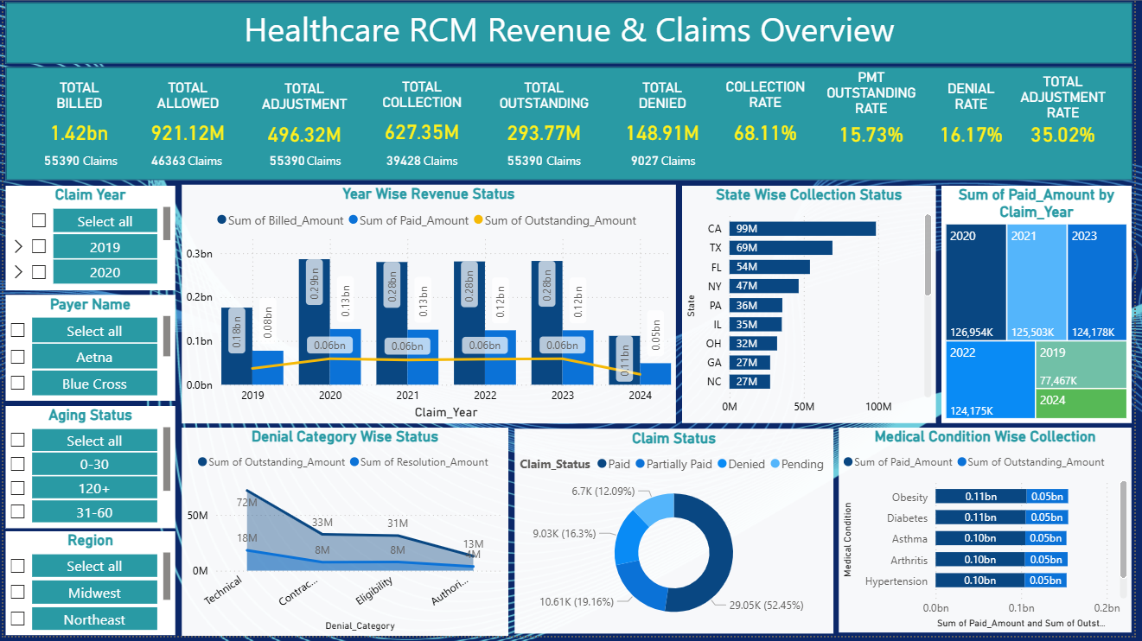

Page-2:
AR Aging & Denial Management — the drill-down/detail page (AR Aging Buckets, Payer Name Wise, Denial Reason wise Outstanding, Facility Wise, Year Wise Resolution)
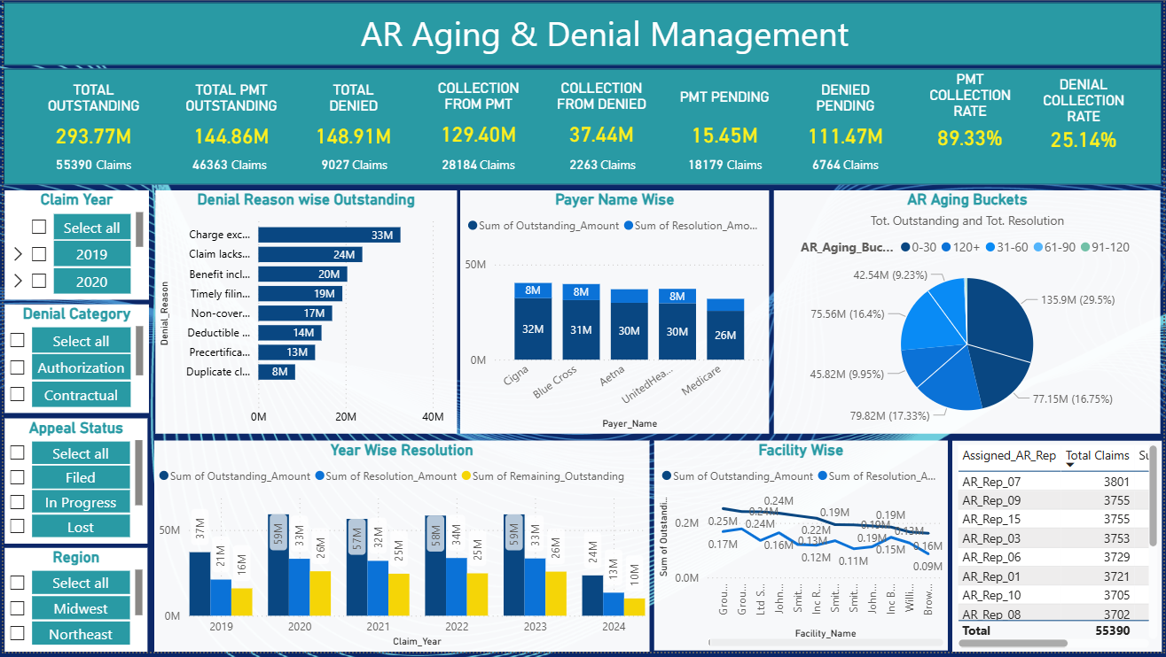

9. Insights & Conclusions

Descriptive — what the data shows
- Overall RCM performance: Across 55,390 claims, the organization billed $1.42B, allowed $921.1M, and collected $627.4M — a 44.3% collection rate, with $293.8M still outstanding.
- Claim outcome mix: 52.4% of claims are fully paid, 19.2% partially paid, 16.3% denied, and 12.1% still pending — meaning nearly 1 in 3 claims never reaches full payment on the first pass.
- AR aging is bimodal, not gradual: 46.3% of outstanding dollars sit in the 0–30 day bucket (normal/fresh) and 27.2% sit past 120 days (chronic), while the 61–120 day middle bands hold under 1% combined — claims either resolve quickly or get permanently stuck, with almost no "slow drift."

Diagnostic — why it's happening
- Denials are a documentation problem, not a payer problem: Technical errors account for 4,323 denied claims and $71.9M (48% of all denied value) — nearly half of all denial dollars trace to claim-formatting/data issues rather than medical necessity or contract disputes.
- Denial rate is statistically flat across payer, age, and admission type: Commercial vs. Government payers (16.31% vs 16.26%), all five major payers (16.0–16.5%), all age bands (13.6–16.5%), and all admission types (16.2–16.4%) show near-identical denial rates — this rules out payer bias or patient-demographic risk as a driver and points squarely at transaction-level (coding/submission) causes.
- Claim age is decoupled from claim value and outcome: The correlation between Days_Outstanding and every dollar field (Billed, Paid, Outstanding, Denied) is effectively 0.00, and average days outstanding barely moves across claim status (279–289 days for Paid vs. Denied vs. Pending) — AR aging is being driven by workflow/follow-up cadence, not by claim complexity or dispute size.

Predictive — what's likely ahead
- Collection rate is structurally stable, not improving on its own: Billed and paid volumes plateaued at ~$280M billed / ~$125M paid per year from 2020–2023 (a consistent ~44–45% collection rate each year); 2024's partial-year pace ($111.4M billed) tracks the same trend, so without a process change, next year's collection rate is likely to land in the same 44–45% band rather than improve organically.
- Technical denials are the highest write-off risk category going forward: They carry both the largest denied-dollar exposure ($71.9M) and the longest average resolution cycle (~295 days vs. ~280 for Contractual/Eligibility); with only 25.1% of all denied dollars ever recovered ($37.4M of $148.9M) and appeals used on fewer than 1 in 10 denied claims, this bucket is on track to keep bleeding cash unless resolution speed improves.

Prescriptive — what to do about it
- Fix claims at the source, not after denial: Since Technical denials are the single largest category and are unrelated to payer or patient mix, investing in front-end claim-scrubbing / pre-submission validation rules (missing fields, coding mismatches) would cut denials broadly across all payers at once, rather than requiring payer-specific fixes.
- Formalize an appeal-triage policy: 46,363 of 55,390 claims (84%) never enter the appeals process at all, yet claims that are appealed win 55.3% of the time (2,263 won vs. 1,829 lost) — routing high-value denials (especially from Blue Cross, Cigna, and UnitedHealthcare, which each carry $58–63M in outstanding AR) into a standing appeals workflow could recover a meaningful slice of the $111.5M in still-unresolved denied balance.

10. Conclusions

This project applied a full Python-to-Power BI revenue cycle management analytics pipeline to 55,390 healthcare claims spanning 2019–2024, moving from data cleaning and exploratory analysis in Python to an interactive two-page Power BI dashboard for ongoing monitoring. The analysis shows an organization collecting 44.3% of billed revenue with denials concentrated in preventable technical errors rather than payer- or patient-driven factors, and with accounts receivable aging in a bimodal pattern where claims either clear quickly or become chronically stuck past 120 days. Diagnostically, the near-uniform denial rates across payer, age, and admission type indicate the problem lies in claim submission quality rather than external bias, while the decoupling of claim age from dollar value suggests workflow and follow-up discipline — not claim complexity — is driving aged AR. Looking forward, the stable 44–45% collection rate across five consecutive years signals that current processes have reached a performance ceiling that won't improve without intervention, particularly around the high-exposure Technical denial category. Prescriptively, the clearest levers are front-end claim validation to prevent technical denials before submission and a structured appeals program to capture the substantial recoverable value currently left on the table — together, these findings translate raw claims data into a concrete, data-backed roadmap for improving cash flow and reducing AR risk.

